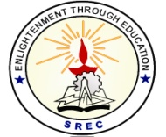**SRI RAMAKRISHNA ENGINEERING COLLEGE**

[Educational Service: SNR Sons Charitable Trust]

[Autonomous Institution, Reaccredited by NAAC with ‘A+’ Grade]

[Approved by AICTE and Permanently Affiliated to Anna University, Chennai]

[ISO 9001:2015 Certified and all eligible programmes Accredited by NBA]

**VATTAMALAIPALAYAM, N.G.G.O. COLONY POST, COIMBATORE – 641 022**

**SREC – IP CELL**

**Date: 24.07.2023**

**Report on Patent Drafting**

The SREC IP Cell conducts a session on patent drafting on 22.07.2023 for faculty members of all the departments. Mr. Muruganantham, Patent Attorney, Coimbatore gave the detailed explanation on patent drafting.

This session on patent drafting exposed the faculty to patent an idea and the process of writing the patent description and claims. There were about 70 faculty members attended the session and got benefitted out of it.

Dr. M. S. Geetha Devasena, Professor/CSE rendered opening remarks of the session and welcomed the gathering, The introduction to the resource person was given by Dr. R. Kingsy Grace, Associate Professor/CSE. Dr. S. Deivanayaki, Assistant Professor (Sl. Grade)/Physics delivered the vote of thanks.

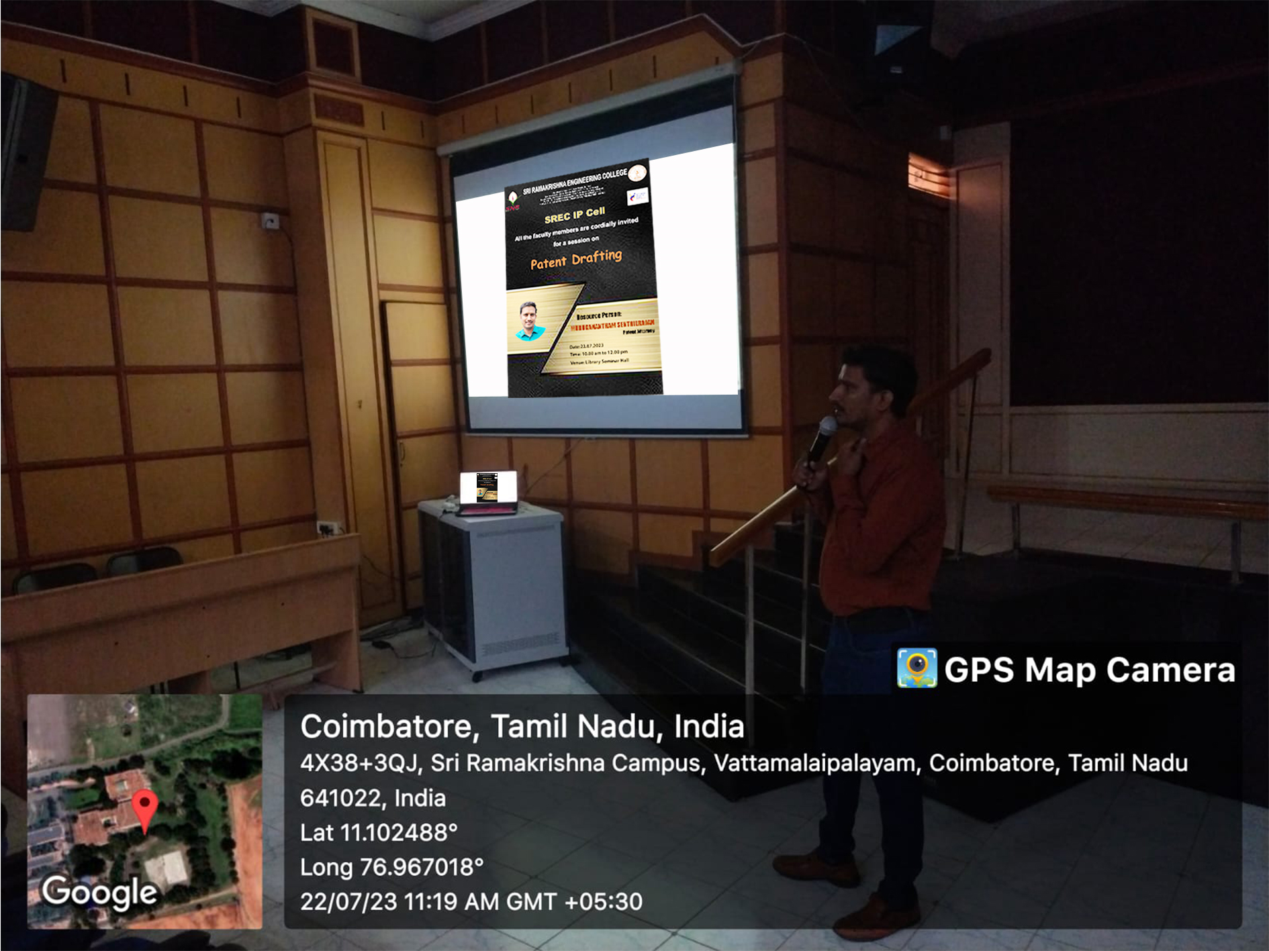

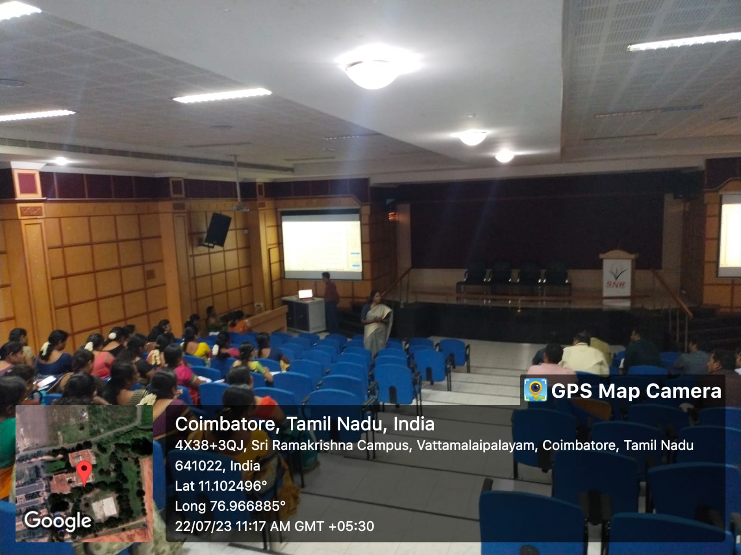

**HEAD – IP CELL**

**Dr. M. S. Geetha Devasena, P/CSE**